AssessProX

### Project Proposal

## 

## Supervisor

Sir Adeel Karim

## Submitted by

1st Neha Batra

{2012219}

2nd Sindhu Kukreja

{2012231}

**Faculty of Computing and Engineering Sciences**

Shaheed Zulfiqar Ali Bhutto Institute of Science and Technology, Karachi.

Table of Contents

**Introduction 3**

**Objective 3**

**Problem Description 3**

**Methodology 4**

**Project Scope 5**

**Solution Application Areas 5**

**Tools/ Technologies 6**

**Expertise of the Team Members 6**

**Milestones 6**

**Project Schedule 7**

**Work Breakdown Structure 8**

**References 8**

**Introduction**

# The "AssessProX" project emerges as a groundbreaking solution to transform the landscape of online learning. The digital age has brought with it remarkable opportunities, but it has also exposed critical gaps in how we approach education, collaboration, and skill development. Recognizing these challenges, "AssessProX" sets out to redefine the way we learn, interact, and thrive in the world of online education.

# **Objective**

# To develop a user-friendly mobile application, AssessProX, that enhances online learning, assessment methods, and collaboration, thereby transforming the online education experience.

# **Problem Description**

# In today's dynamic educational and professional landscape, the process of assessment plays a pivotal role in evaluating the knowledge, skills, and competencies of individuals. However, the traditional methods of assessment often fall short in meeting the demands of modern education and the workplace. This is where AssessProX comes into focus, addressing a set of critical challenges in the realm of assessment.

# Fragmented Learning: Current online education platforms offer fragmented learning experiences, lacking cohesion and continuity.

# Limited Engagement: Engagement and collaboration among learners are often minimal, hindering motivation.

# Lack of Personalization: One-size-fits-all approaches neglect individualized learning paths and preferences.

# Progress Tracking: Learners struggle to monitor progress effectively, leading to a lack of direction.

# Inefficient Communication: Current platforms lack efficient communication tools for learners.

# Access to Resources: Accessing supplementary learning materials is cumbersome and fragmented.

# Exam Preparation: Tools for assessments and exam preparation are often limited.

# Skill Recognition: Current platforms lack mechanisms for recognizing achievements and skills.

# Collaboration Barriers: Learners lack effective collaboration and negotiation hubs for teamwork.

# Complex Enrollment: Enrolling in specific courses can be cumbersome; class code joining streamlines the process.

# **Methodology**

# **Technology Selection:**

# Utilize the Flutter framework for developing the mobile application's frontend due to its cross-platform compatibility and rapid development capabilities. Implement MongoDB as the database system for its flexibility and scalability in handling data.

# **Design and Wireframing:**

# Begin with designing wireframes and UI mockups for the AssessProX mobile application to establish the user interface's structure and flow.

# **Development:**

# Develop the frontend of the mobile application using Flutter. Implement user interfaces for features Set up a backend server using a technology stack compatible with Flutter (e.g: Dart). Implement necessary APIs for user registration. Utilize Flutter widgets libraries for UI components and a responsive design.

# **Database Integration (MongoDB):**

# Connect the backend server to the MongoDB database. Create database schemas to store user information, assessment data, and transaction records. Implement CRUD (Create, Read, Update, and Delete) operations for data management.

# **Payment Gateway Integration:**

# Integrate a suitable third-party payment gateway service into the backend for secure transaction processing. Implement payment processing logic and ensure data security and compliance with payment regulations.

# **User Testing and Feedback:**

# Conduct user testing phases to gather feedback on the application's usability and functionality. Make iterative improvements based on user feedback to enhance the user experience.

# **Security and Data Privacy:**

# Implement robust security measures to protect user data, payment information, and sensitive information. Regularly perform security audits and updates to address potential vulnerabilities.

# **Scalability and Performance:**

# Design the architecture to be scalable, capable of handling increased user loads and data growth. Continuously monitor application performance and optimize as needed.

# **Documentation and Training:**

# Prepare comprehensive documentation for developers and end-users. Create user training materials or guides to assist users in effectively using the application.

# **Deployment:**

# Deploy the mobile application and backend services to suitable hosting environments. Ensure smooth deployment processes and monitor system health after deployment.

# **Testing and Quality Assurance:**

# Perform thorough testing, including unit testing, integration testing, and user acceptance testing. Address any identified issues or bugs promptly.

# **Project Launch:**

# Launch the AssessProX mobile application to the intended users. Implement marketing and user acquisition strategies.

# **Post-Launch Maintenance:**

# Continuously monitor application performance, address user feedback, and release updates as needed to maintain and improve the application.

# **Project Closure:**

# Conduct a formal project closure, including documentation of lessons learned and knowledge transfer to stakeholders.

# **Project Scope**

# The project scope for AssessProX involves the development of a mobile application aimed at revolutionizing online learning. This innovative project seeks to address critical gaps in online education, collaboration, and skill development brought about by the digital age. AssessProX aims to redefine the online learning landscape, providing users with an engaging, interactive, and empowering learning experience through its mobile application.

# **Solution Application Areas**

1. K-12 Education
2. Higher Education
3. Skill Development
4. Community Education
5. Test Preparation
6. Home schooling
7. Educational Startups
8. Tutoring and Coaching

**Tools/ technologies**

To develop the AssessProX software application, you would require a combination of hardware (HW) and software (SW) tools and technologies. Here is a list of some commonly used tools and technologies for such a project:

**Hardware:**

Mobile, Laptop, PCs, Tablets

**Programming Languages:**

Flutter

**Database:**

MongoDB

**IDE:**

Android Studio

**Expertise of the Team Members**

Our team comprises of two members including Neha Batra, Sindhu Kukreja and our project advisor Sir Adeel Karim. Both the members have basic knowledge of database creation, android development and documentation. In addition, both members intend to learn courses that are relevant and required for the project.

**Milestones**

1. QR-Based Quiz: Users can create and participate in quizzes using QR codes. These quizzes can cover a wide range of topics and are accessible to anyone with a QR code scanner.

2. Polling: A digital platform or application that provides users with access to various polling reports. These reports typically contain data and statistics gathered from surveys or polls and are presented in a structured and visual format to facilitate analysis and decision-making.

3. Live Scoring: Real-time scoring and leaderboard updates make quizzes competitive and interactive. Users can see their progress and compare their scores with others.

4. Marketplace: A marketplace section allows users to buy and sell educational resources such as study materials, e-books, and course materials. It serves as a hub for educational resources.

5. Communities: Users can directly communicate from the platform to facilitate communication and discussion related to their interests or courses.

6. Reminders: The platform sends automated reminders for upcoming quizzes, assignment due dates, and other important events, helping users stay organized.

# 7. Resume Level Badges: As users complete quizzes and achieve milestones, they earn badges that can be displayed on their profiles, showcasing their expertise and progress.

# 8. Mock Tests: Besides regular quizzes, there is a section for mock tests that simulate real exam conditions, helping users prepare for assessments.

# 9. Recommendation Engine: The platform uses algorithms to suggest quizzes, resources, and groups tailored to each user's interests and performance.

# 10. Assessment dashboard: Assessment dashboard paly a important role in providing a comprehensive overview of assessment data and performance metrices. Its main purpose is to help users leverage assessment data to make informed decisions and improved learning outcomes.

# 11. Class code joining: A feature or functionality within an application, often used in educational or collaborative environments that allows users to join specific classes, groups, or communities by entering a unique code or identifier. It simplifies the process of accessing and participating in predefined groups.

# 12.Progress Reports on Request: Users can request and generate progress reports for their educational journey, including quiz performance, assignment completion, and more.

# 13. Assessment purchase and sell: The capability within an online platform or system to browse, select, and acquire assessments or tests. Users can typically purchase assessments related to various subjects or skill sets, often used for educational or professional purposes.

# 14. Payment gateway: A secure online service that facilitates electronic financial transactions by acting as an intermediary between a user, a seller, and the financial institution. Payment gateways enable the authorization and processing of payments made via credit cards, digital wallets, or other payment methods.

# **Project Schedule**

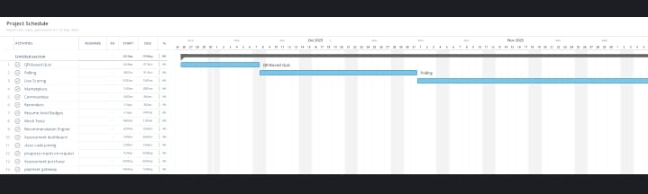

# **Work Breakdown Structure**

# 7th Semester

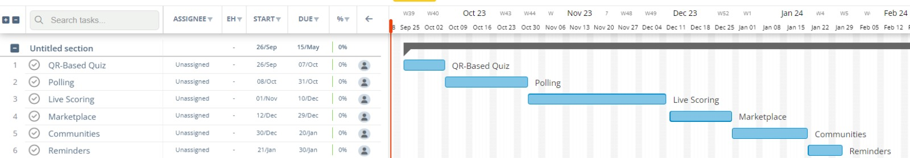

# 8th Semester

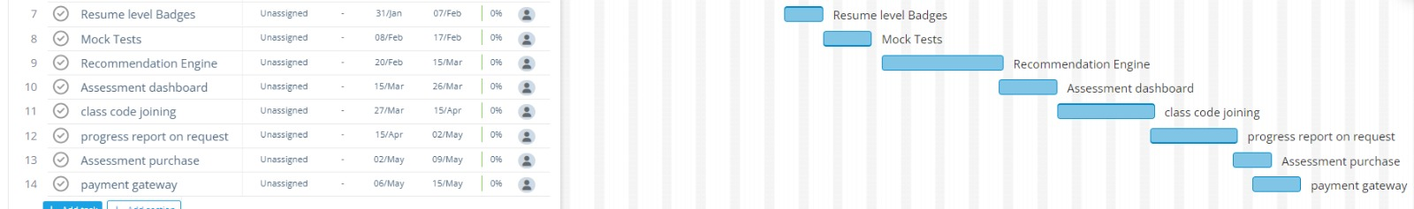

**References**

# https://insightsoftware.com/promos/drive-growth-with-embedded-analytics/?utm_source=bing&utm_medium=cpc&utm_campaign=sea-direct-logi-datavisualization&analytics-na-tofu&utm_content=1295225134499600&utm_term=interactive%20visualization&msclkid=eddd815eb8da1d9c40ece455ddb1cf78

# https://www.makeuseof.com/best-interactive-apps-classroom-workplace/

# https://sched.com/blog/the-best-free-apps-for-interactive-learning/